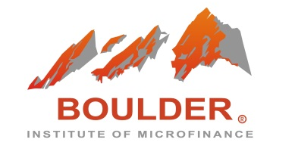

2024 BOULDER MFT PROGRAM IN ENGLISH

SAVE YOUR SPOT FORM

Please read the form below carefully and provide the requested information

* mark means mandatory field

PERSONAL DATA
Which languages do you speak fluently? *
First name / Given name *
Family name(s) / Surname *
Gender *
WORK INFORMATION
Institution you work for *
Type of institution *
Job Title *
Job Type *
Level of responsibility *
City *
Country *
Phone: (country code) (city code) (phone number) *
E-mail *
PERSONAL INFORMATION
Second E-mail address
Cell Phone: (country code) (city code) (phone number)
SPONSOR
Type of sponsor *
Name of tuition sponsor *
Contact person *
Sponsor contact's email *
Phone: (country code) (city code) (phone number) /extension *
EXPERIENCE
What are your expectations for the Boulder MFT? What issues concern you most? *
How would you rate your knowledge of microfinance? * | Beginner: 1 year or less
 | Intermediate: 2-4 years
 | Advance: 5 years or more
How did you learn about the Boulder MFT program? *
Short bio for participant directory (no more than 240 characters)*

PLEASE ATTACH A PASSPORT SIZE PICTURE IN JPG FORMAT TOGETHER WITH THIS REGISTRATION FORM

Your registration for the Boulder MFT Program will operate as a grant of irrevocable and unrestricted permission to the Boulder Institute of Microfinance, its employees, agents or representatives, to take, use and publish: photographs/digital images, digital video, audio recording or quoted remarks, educational or other PowerPoint or presentation materials of you or prepared by you for use in promotional or educational materials. These materials might include printed or electronic publications, web sites, blogs or interactive media or other electronic communications. In addition, your name and identity may be revealed in descriptive text or commentary in connection with the image(s).

I wish to receive Boulder Institute of Microfinance information:

Yes |  |  | No

